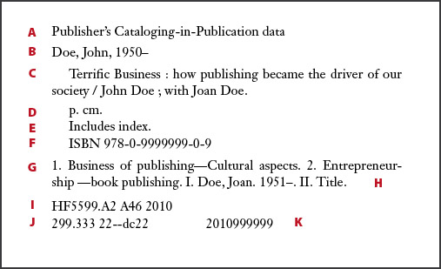
CIP is based off of records submitted by the publisher during the publishing process. As such records, are not meant to be a source for cataloging; but can serve as a reference.
A. Alerts the librarian the CIP was prepared by or for the Publisher
B. The main entry under which the book is cataloged, the author’s name (or what was submitted by the publisher as the author).
C. The title, followed by a statement of responsibility, in this case assigning authorship to John and Joan Doe.
D. Physical description of the book, blank since the book is not yet published.
E. Notes whether an index or other bibliographical entries are in the book.
F. ISBN
G. Subject headings, conforming to Library of Congress usage. The subject headings MUST be authorized Library of Congress subject headings.
H. Indicates other ways the book will be cataloged, here by title as well as by author.
I. Library of Congress classification number.
J. Dewey Decimal classification number.
K. Library of Congress PCN. Note the year the number was issued is in the first four digits.

